COM535 Cyber Security Lab

Instructions

- Visit https://www.hacksplaining.com/lessons

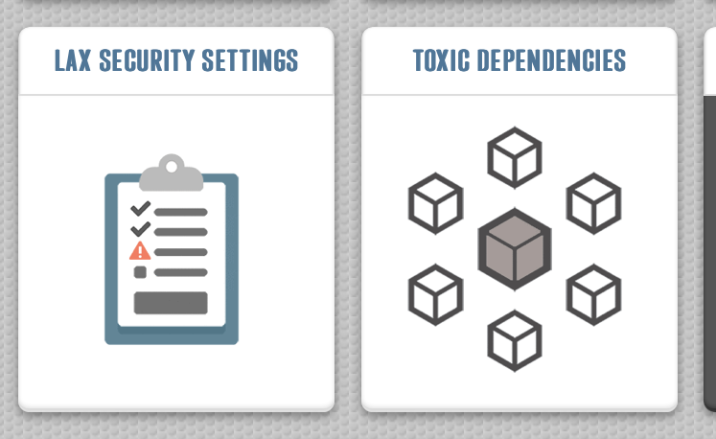

- Complete the two vulnerability lessons which are Lax Security Settings, Toxic Dependencies

Phishing

- Complete Phishing Analysis Fundamentals
https://tryhackme.com/jr/phishingemails1tryoe

Help video: https://youtu.be/InczELBuUC0

- Complete Phishing Emails in Action
https://tryhackme.com/jr/phishingemails2rytmuv

Help Video: https://youtu.be/838hIomnQvg

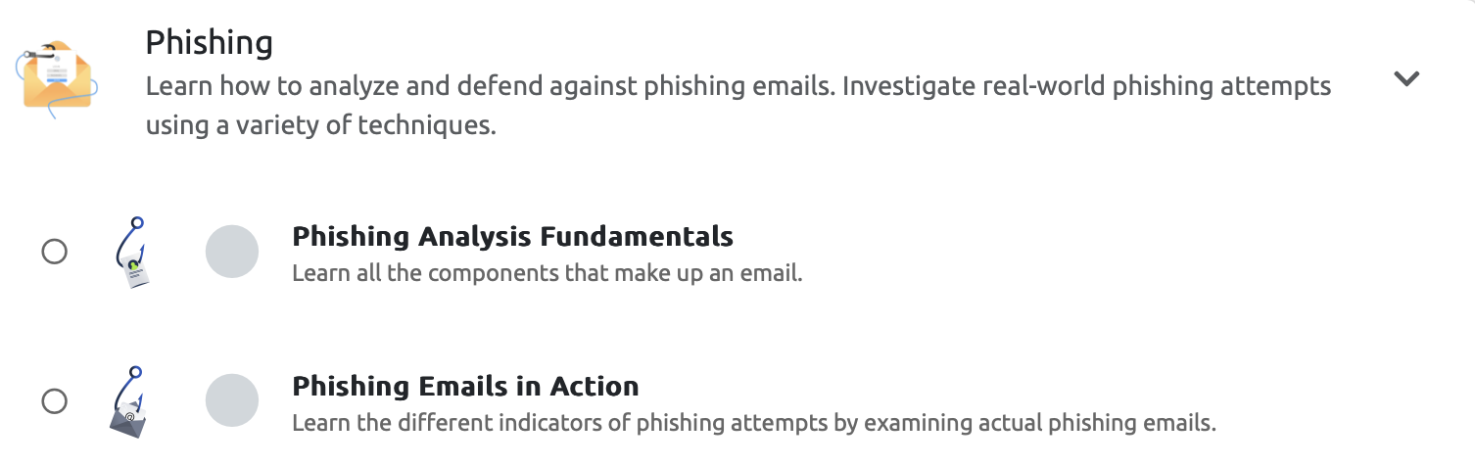

Introduction to Detection Engineering

- Complete Intro to Detection Engineering
https://tryhackme.com/r/room/introtodetectionengineering

Help video: https://www.youtube.com/watch?v=EFp5KIr4pvQ

